DVD Emporium

By

Aakash Sharma

Level-6

Final Project

Table of Contents

Project Proposal 3

Goals and Objectives 3

Project Scope 3

Project Specifications 3

Target Audience 3

Project Deliverables 4

Resource Requirements 4

Project Tasks and Milestones 4

Project Assumptions 5

Project Report 5

Detail Design 6

Home Page 6

Registration Page 6

Login Page 7

All Order History Admin View 7

Movie Page Admin View 8

All Movies Visitor View 8

All Directors Visitor View 9

Movie Details Page Visitor View 9

Project Testing 10

User Manual 10

Summary 10

System Configuration 10

User Access Levels 10

# 

# Project Proposal

## Goals and Objectives

The main goal or aim of the project is to implement an online web application named “DVD Emporium”. The main purpose of the application is help people to find movie DVD of different genres, studios and directors. In this application there are two types of users- admin and registered visitor. Admin has different functionalities as compare to registered visitor. Admin can add, edit, delete and check details of all genre, studios, directors and movie. Admin can delete and check details of the movie DVD orders. Also, user can place order of needed DVD.

## Project Scope

The scope of this project is to implement an app named “DVD Emporium” with the help of which user can find any movies and order them. The duration of the project is 20 working days which is equals to 4 weeks.

## Project Specifications

* Admin login/logout
* Add, edit, delete and check details of movie by admin.
* Admin can delete, edit and check studios companies.
* Admin can delete and check director and genres of Movies.
* Admin can register new admins.
* Registered Visitor can login/logout.
* New Visitor can register.
* Registered Visitor can order the Movie available on site.

## Target Audience

The target audience for this project is the movie lover people who would like to enhance watch movies as per their will. The age can go from 5 plus to 100 plus.

## Project Deliverables

The deliverables of the project are:

|  |  |
| --- | --- |
| **Deliverable** | **Description** |
| Final Report | This will be the final report of the project. |
| Coding | The executable code of the project will go under this. |
| Documentation | This portrays the documentation of the project. |
| Testing | All the test details will be covered in this part. |

## Resource Requirements

* Windows Operating System.
* Microsoft word for documentation.
* Asp.net MVC Framework
* 64-bit Processor and 4 GB or more RAM
* Identity framework- ASP

## Project Tasks and Milestones

|  |  |  |  |  |
| --- | --- | --- | --- | --- |
| **Tasks** | **Week-1** | **Week-2** | **Week-3** | **Week-4** |
| Brainstorming and analysis |  |  |  |  |
| Planning and initial meeting Project Proposal document. |  |  |  |  |
| Database Design and UI Design |  |  |  |  |
| Identity framework implementation |  |  |  |  |
| Coding for admin and reporter |  |  |  |  |
| Testing |  |  |  |  |
| Final Documentation and closing |  |  |  |  |

## Project Assumptions

Following are the assumption made while implementing the project:

* One admin and registered visitor will be registered by default.
* Application will be free and open source.

# Project Report

#### Functional and Non-Functional

|  |  |
| --- | --- |
| Users | Functional |
| Admin | * Login/logout * Register new admins * Admin can add, edit, delete, check details for genres. * Admin can edit, delete and check details for movies. * Admin can delete and check details for the studio and director of movies. |
| Customer | * Can view details of genres, studios, directors and movies * Can order the movie DVD * New customers can register for free. * Login using valid credentials |
|  | Non- Functional |
|  | * High speed * Fast Loading time * High performance and security * All browsers compatibility. |

## Detail Design

### Home Page

The main landing page of the application. On navigation bar options are- Home, All Studios, All Directors, All Movies, Register, Login.



### Registration Page

With the help of this page, new registered visitor can sign up for the app

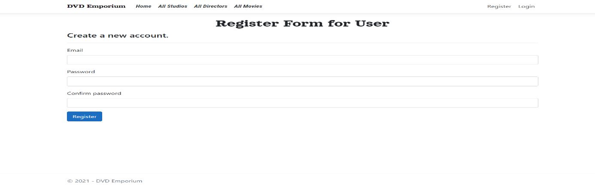

### Login Page

With the help of this page, registered visitor and admin can login to the application using their valid credentials.

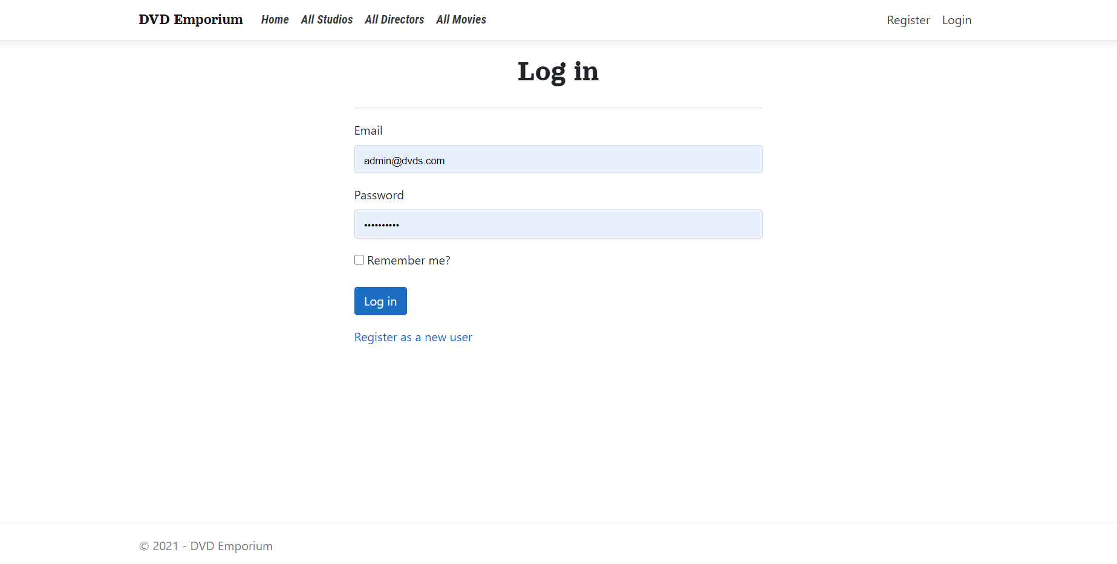

### All Order History Admin View

This page highlights all the Order History available on the application. Admin can delete and check details of the existing ones.

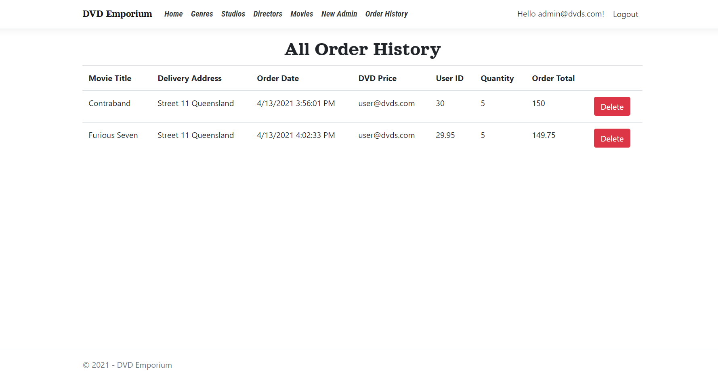

### Movie Page Admin View

With the help of this page admin can manage the movies by editing, deleting and checking their details.

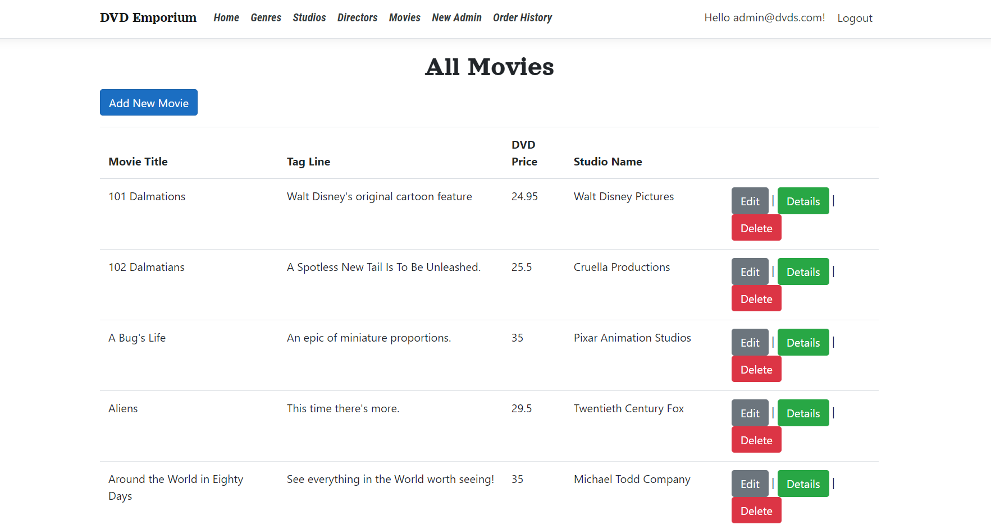

### All Movie Page Visitor View

With the help of this page Visitor can view All Movie details.

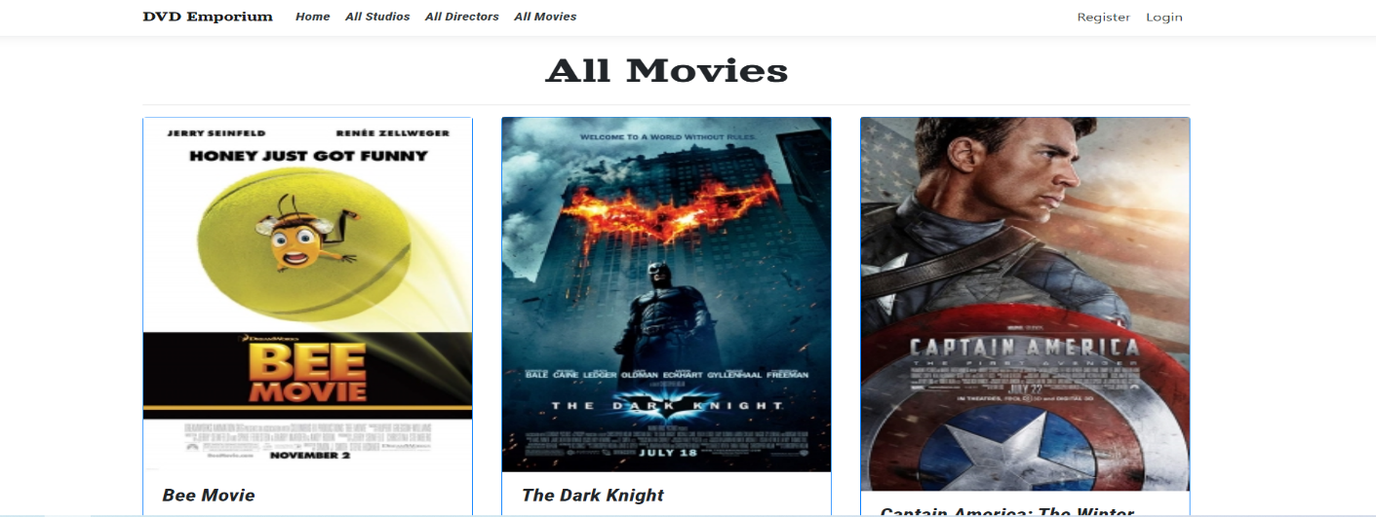

### All Director Visitor View

With the help of this page visitor can check the details of the directors and their movies details.

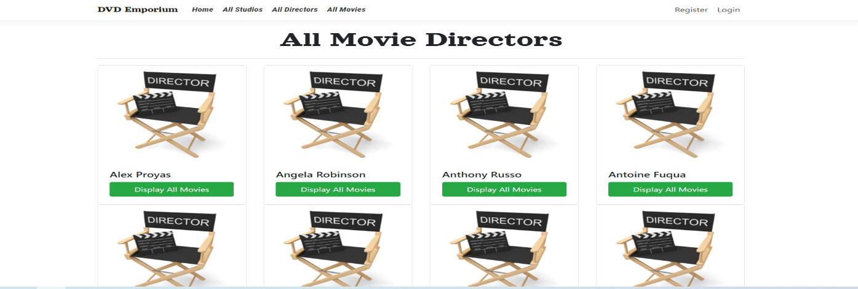

### Movie Details Page Customer View

This page shows the Movie details and pricing of the movie DVD.

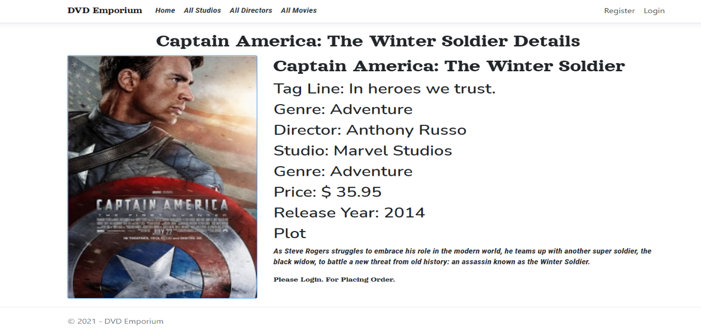

## Project Testing

The testing file for usability testing is attached as [usability test.xlsx](usability%20test.xlsx)

# User Manual

The main purpose of the application DVD Emporium is to help people to find movie DVD of their choice based upon their choice. In this application there are two types of users- admin and registered user or visitor customer. Admin has different functionalities as compare to customers. Admin can add, edit, delete and check details of studios, genres, directors and movie DVD entries. Also, admin can delete, and access details of the User Orders made by the visitor.

## Summary

### System Configuration

This app will be useful to for distributing mobile information in presentable format.

### User Access Levels

Only registered users can access the features of this application.

* **Admin:** Admin has full access of the app can register new admins.
* **Registered Visitor:** New visitor can register and existing can login using their own credentials. They have limited access.